Java Life

Frank Torchia

CS 1699 - DELIVERABLE 4: Performance Testing Conway's Game of Life

Summary

Profiling the application proved to be difficult initially. I encountered many problems setting up the environment for VisualVM. After a good while of confusion I realized that the reason VisualVM was not able to run the application is that the arguments set were not letting the program run long enough for VisualVM to begin profiling so I upped them. The seed values I eventually used were 120 76 83 1200. Once the application began profiling I went to the profiler tab and clicked the CPU button for it to monitor CPU time alloted to certain functions. On initial profiling I found that it was spending an inordinate amount of time in the toString method as seen in the screenshots below. The initial runtime with the original toString algorithm was 5 minutes and 43 seconds. After refactoring the toString method using the java predefined method of StringBuilder and its functions the very same program with the same seed values took only 1 minute and 14 seconds to run. Instead of the method used as original I merely changed all the =+ string concatenations to .append() from the StringBuilder library. Tried to come up with unit tests to test toString to no avail. Only able to test whether or not the string returned was null.

Original Algorithm

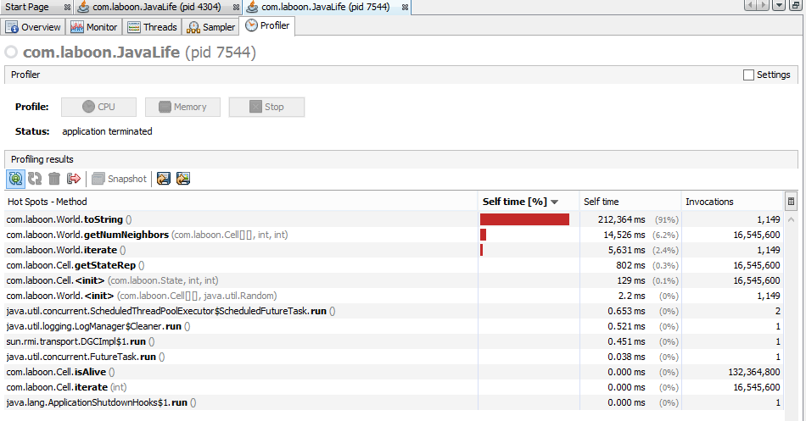

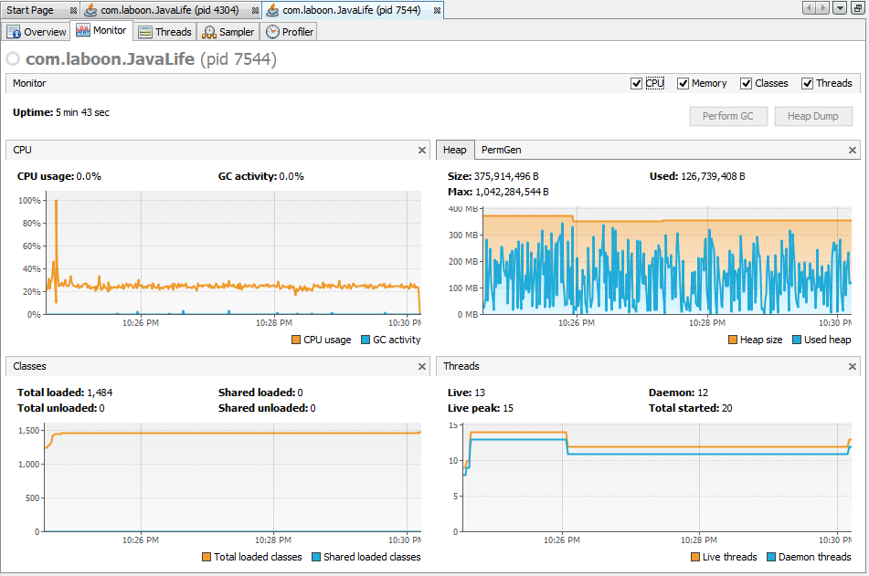

With refactored algorithm

